**Clearing Generator Faults by Controller**

Evolution 1.0 and 2.0 Controller – Press the OFF key, then the ENTER key. To return to automatic mode press the AUTO key.

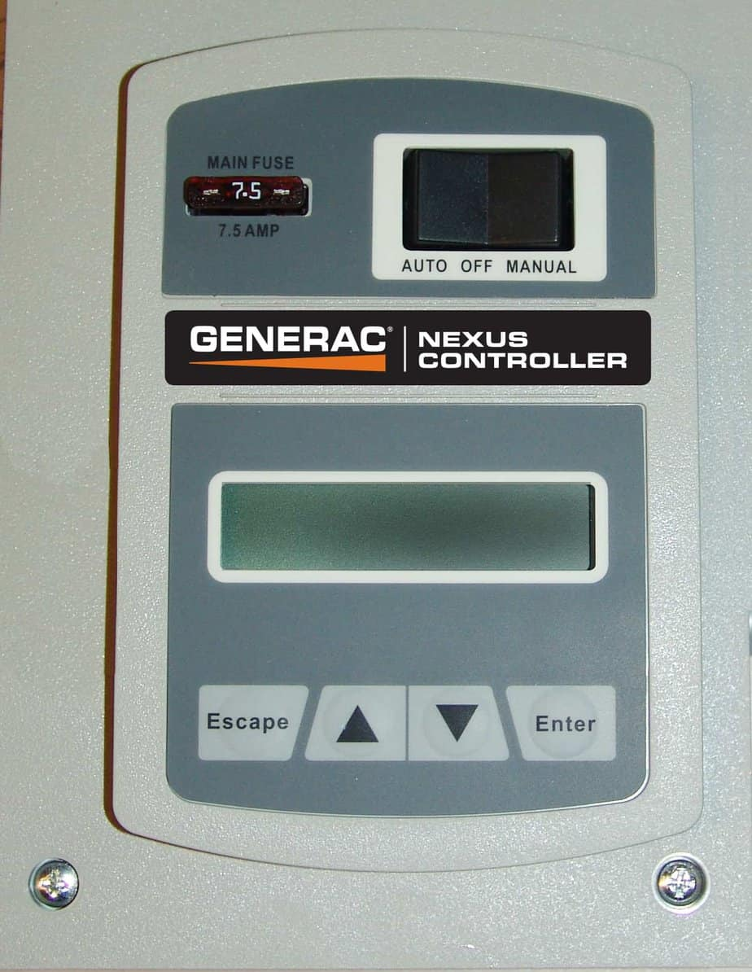

Nexus Controller – Move rocker switch to the OFF position and press the ENTER key. To return to automatic mode move rocker switch to AUTO.

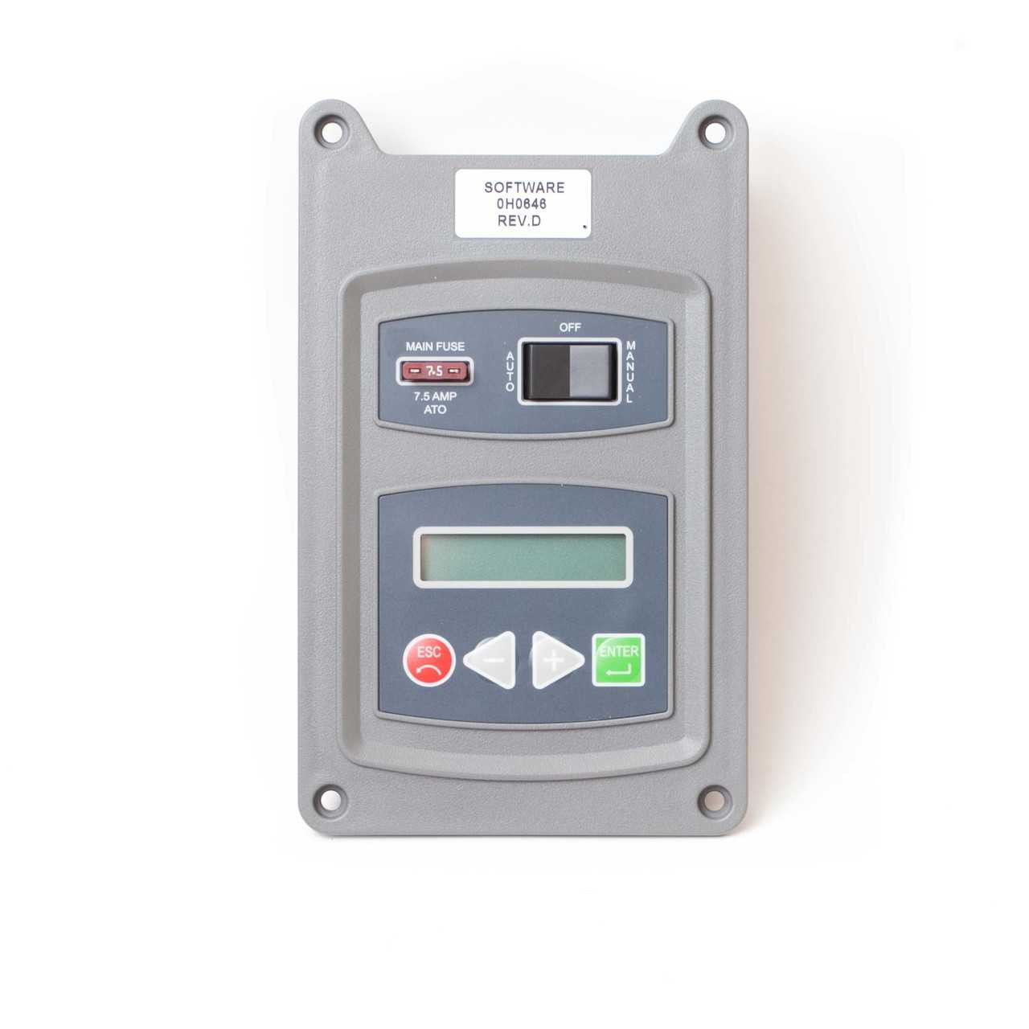

Pre-Nexus 2008 Controller – Move rocker switch to the OFF position and press the ENTER key. To return to automatic mode move rocker switch to AUTO.

Pre-Nexus 2008 8kw Controller – Move rocker switch to the OFF position and press the ENTER key. To return to automatic mode move rocker switch to AUTO.

Square body Pre-2008 Controller – Move rocker switch to the OFF position. To return to automatic mode move rocker switch to AUTO.